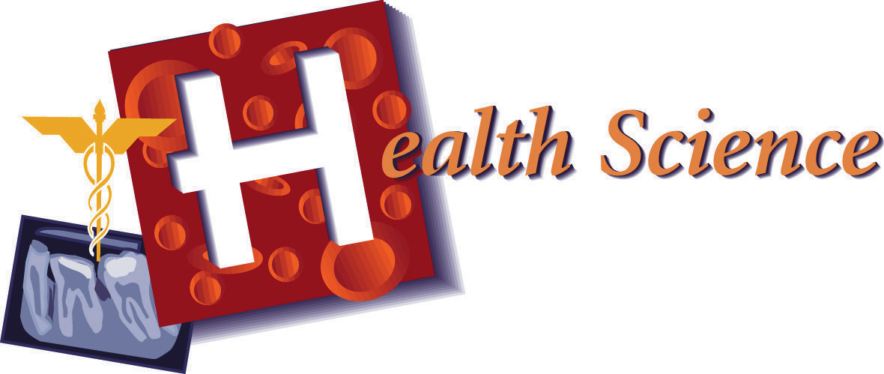

Ingrid Ramirez and Terry Dixon
February 27, 2009
5th Period
Technology Systems
Health Science Industry on Dentistry

Dentistry

In the Health Science Industry, there are various opportunities to choose from. Whether it’s cleaning teeth, curing illnesses, or checking a child’s health, we are all helping one another and showing us how to live a healthier and better life. For our project, we chose the Dentistry occupation. What we predict will happen in the next ten years for the Health Science Industry in Dentistry is that it will expand more of its horizon. The technology used now might improve to much more safer tools that should be more effective. This industry has a pretty slim chance of reaching its moribund state because of the many people who need to repair and clean their teeth, mold for dentures, and apply braces. Having health teeth and gum results in having very few chances in getting diseases and having your teeth removed. Though, becoming a dentist is not as easy as it looks. It takes dedication, smarts, and a lot of practice.
In order to become a dentist, you have to know the many subjects that deal with the mouth. You also have to be aware about what you’re doing and there are some skills/ abilities that you would need to acquire. In order to study to become an orthodontist, the knowledge needed to know is: Medicine and Dentistry, Biology, English Language, Customer and Personal Service, Administration and Management, Psychology, Education and Training, Sales and Marketing, Chemistry, and finally, Economics and Accounting. Medicine and Dentistry is the knowledge of the information and performances which are required to diagnose and treat human injuries and diseases.
The most primary skills one needs to have are active listening, critical thinking, equipment selection, and time management. Active listening is having your full attention to what the patients are saying and to take the time to understand the points that are being told. Critical thinking is to use logic and reasoning to find alternative ideas and seeing its capability. Equipment selection is another main important skill which determines the type of tools and needed to accomplish the task for no other tool would do the same job. Another main important skill that is needed is time management. Time management is the term which is used to manage the time of the task and of them. We would not like to be in the office for hours, messing up everyone else’s schedule or being rushed out because of little time and doing a poor job. All of these, including many others, are an important asset to this particular job.
A typical day in a dental office is reviewing the patients’ previous paper work from their last visit, their usual cleaning, and informing the children how to correctly and how often to brush and floss their teeth. Other wise, assembling braces and closing cavities can also be found in their schedule if the patient needs it. But of course, you can’t just stick your hands in their mouth, you need proper tools. In order to protect yourself and the patient from any diseases masks for the protection of your nose and mouth, gloves for your hands, and safety goggles to prevent anything from popping into them while cleaning someone’s mouth. The minimum education needed for this occupation is a bachelor's, but some might require either a Ph.D. or a master’s degree. Many of the studies needed have to be practiced and have to be at least five years of experience. Also, you have to be trustworthy and be tolerable to stress because this job is not like baking cookies. What you say has to be accurate and what you do has to be perfect, or very close to perfect, because if not, you will not be seeing them ever again.
So, in all, becoming a dentist requires a high level of knowledge, patience, and understanding to those who are new to everything. We have to have self control of our selves and try to just take a deep breath and just do the job we love. It would not be cool if you’re working in this section of the Health Science Industry and you dreaded working there. You have to appreciate your job, no matter what the circumstances may be. Even though some jobs look fun and easy, you have to operate and investigate the requirements. Not everyone is meant to be a specific someone, but we will not have to worry about this industry meeting its end. Many people would like to help others because they wouldn’t want them to suffer and why wouldn’t they want a great a smile. If you want to be a dentist and if you know you have got what it takes, then the Health Science Industry in Dentistry is right for you.

